Marketing to do List:

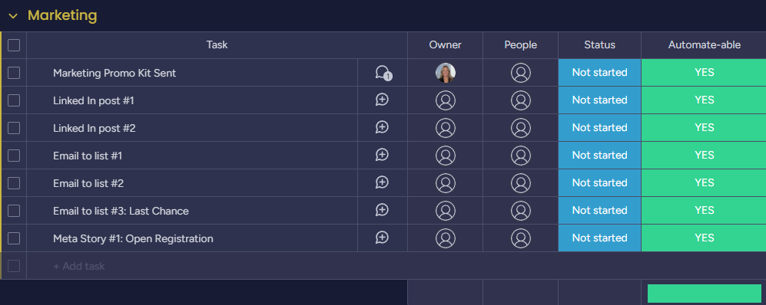

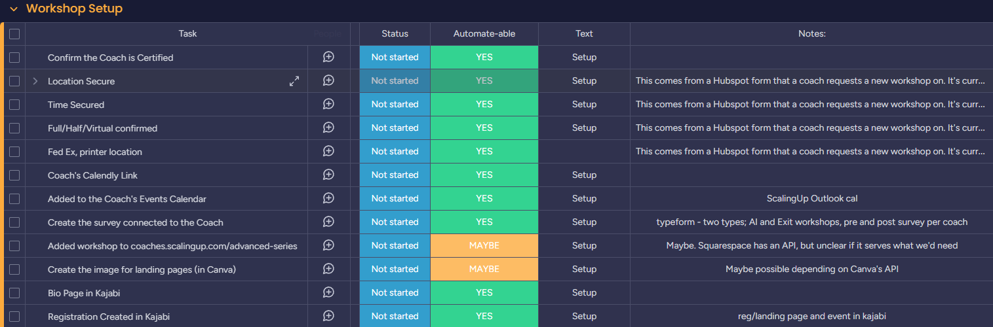
Workshop Development to do List:

